1. Write a program in C to read n number of values in an array and display them in reverse order.

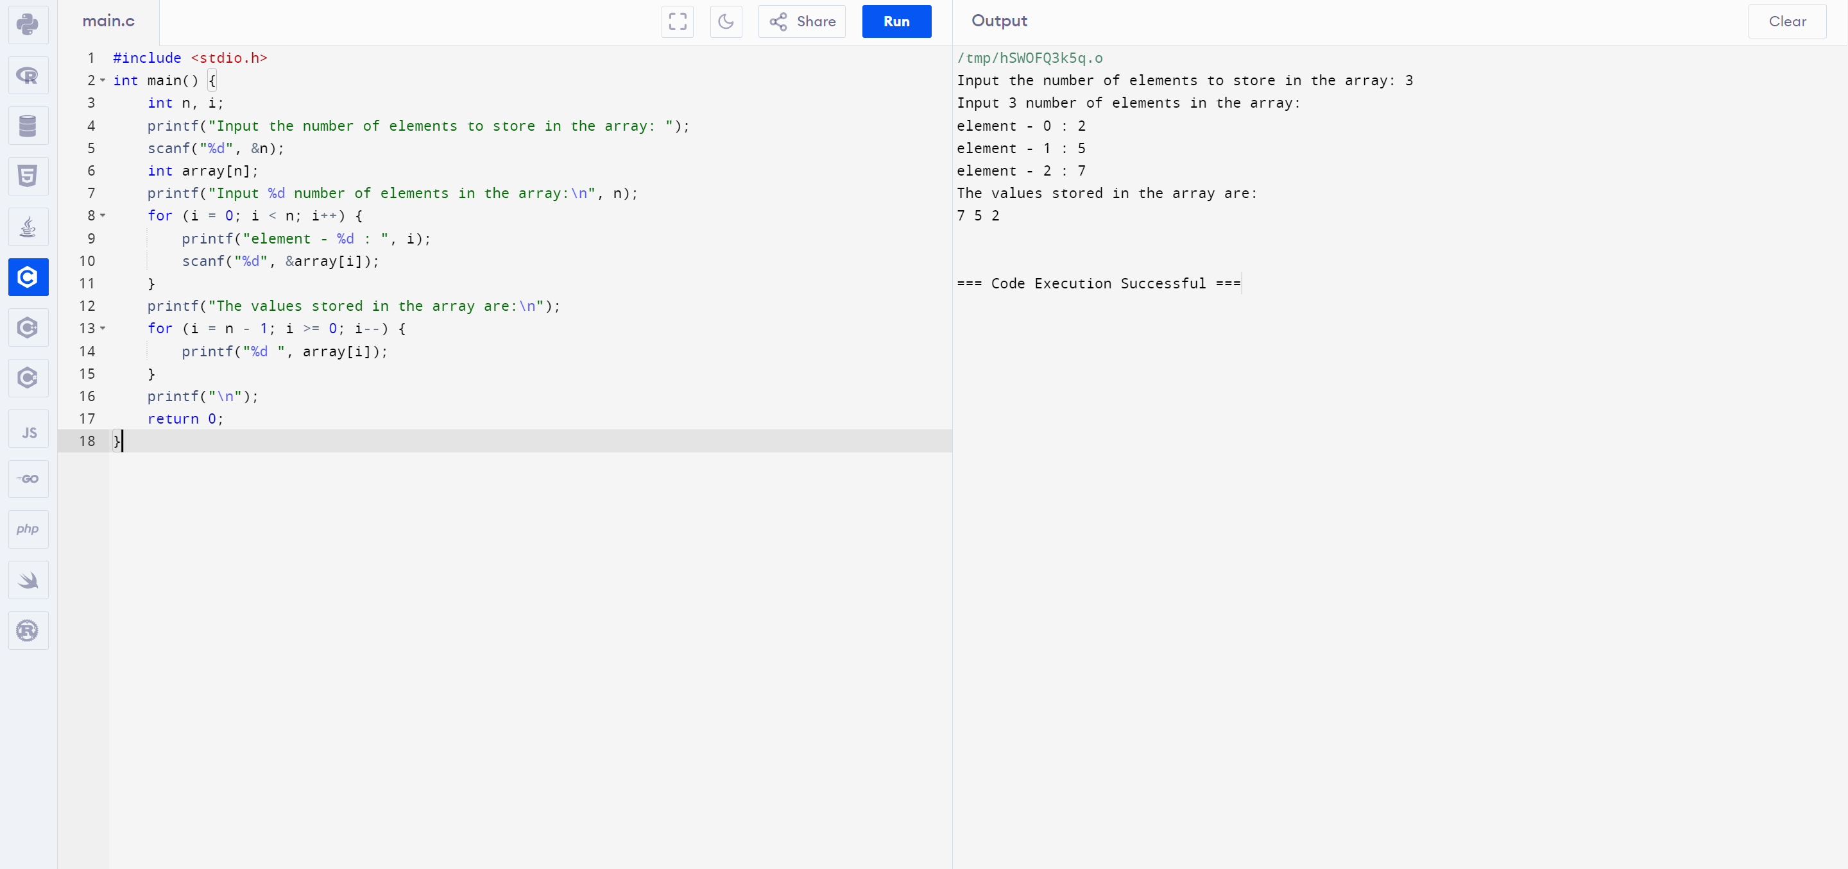

1. Implement a C Program for AVL tree and perform Insertion and Deletion of Nodes

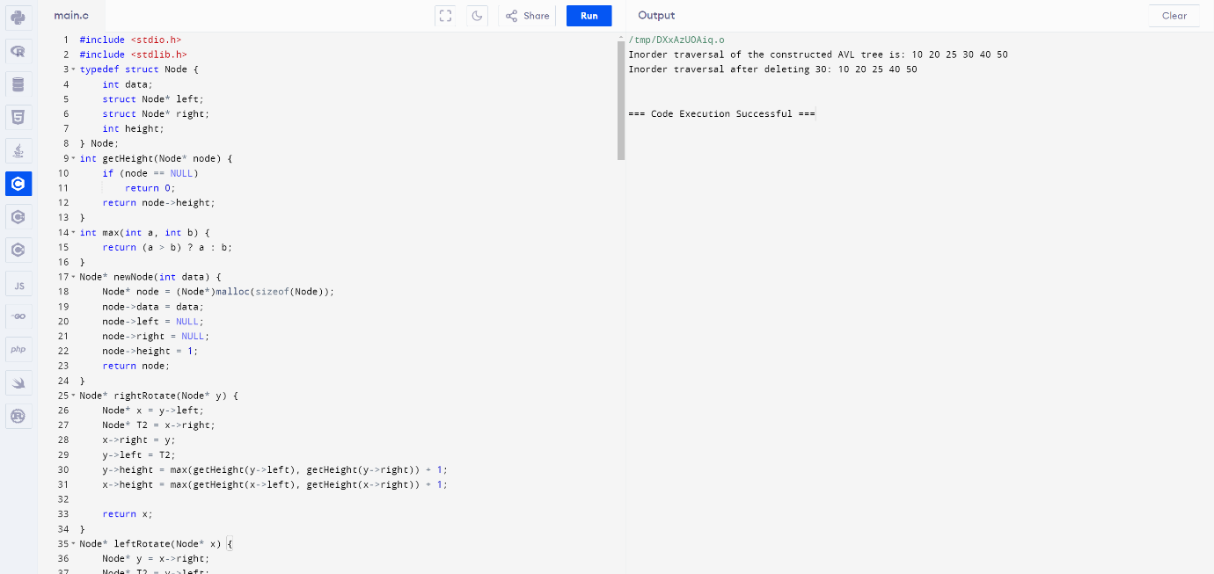

1. Implement a C Program to Check for a valid String

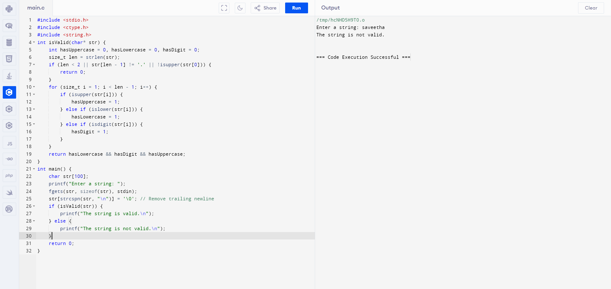

1. Implement a C Program whether it is a Valid stack

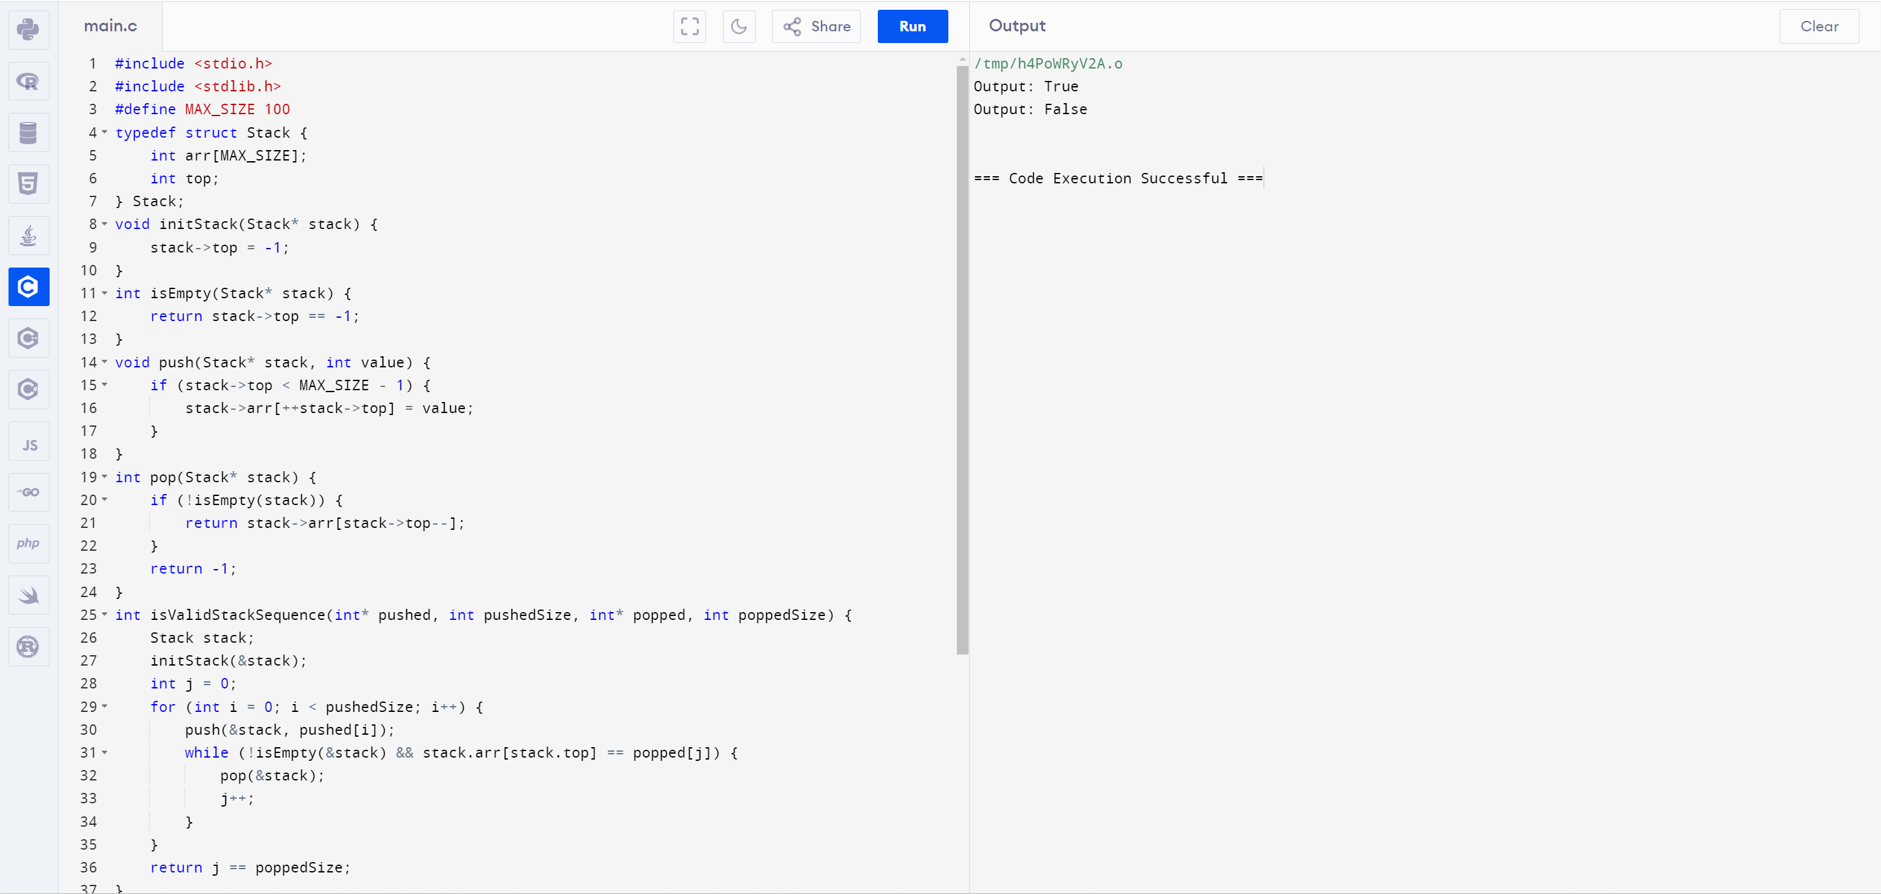

1. Implement a C Program to Merge two Arrays

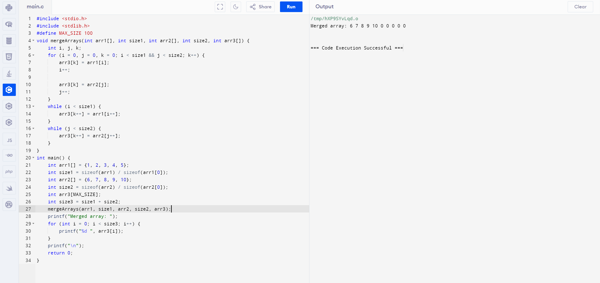

6.Implement a C Program for Graph to Identify shortest path

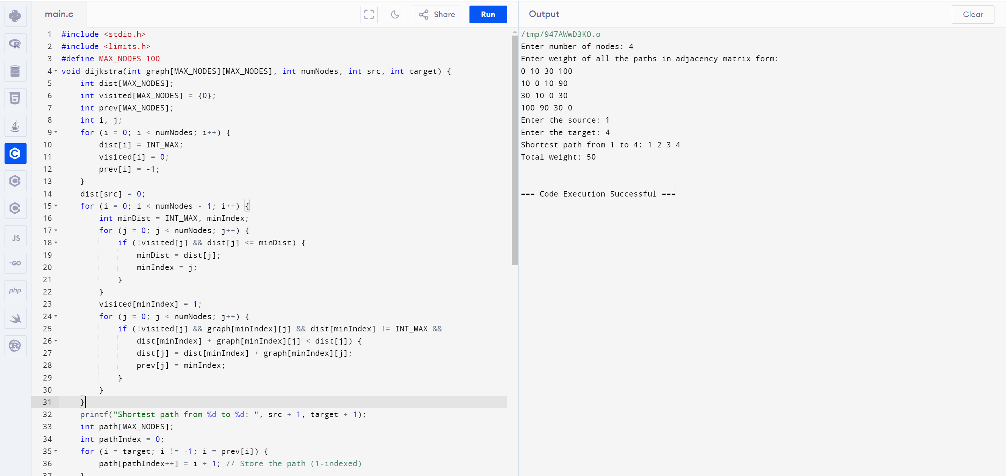

7.Write a program in C to count the total number of duplicate elements in an array.

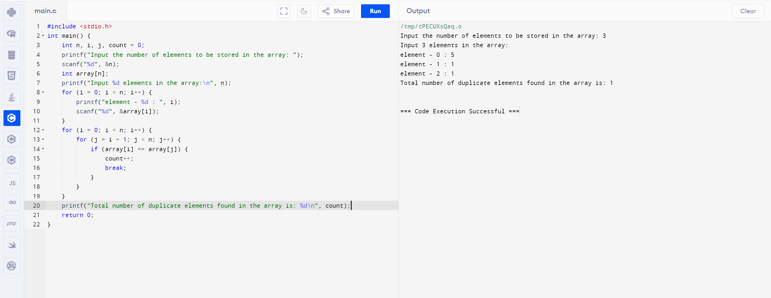

8. Implement a C Program Traveling Salesman Problem to Identify shortest path Given a set of cities and distances between every pair of cities, the problem is to find the shortest possible route that visits every city exactly once and returns to the starting point.

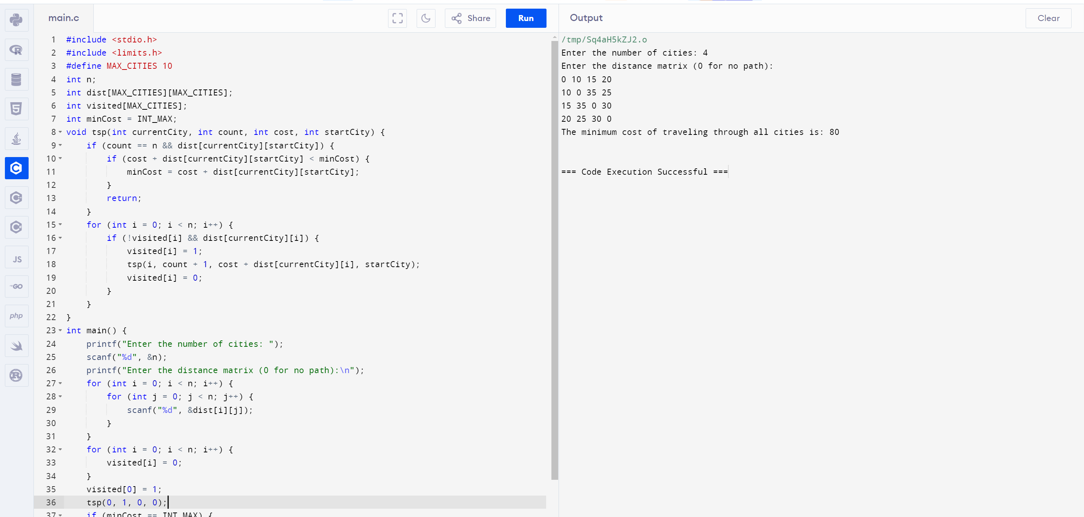

9. Implement a C Program for Merging of list

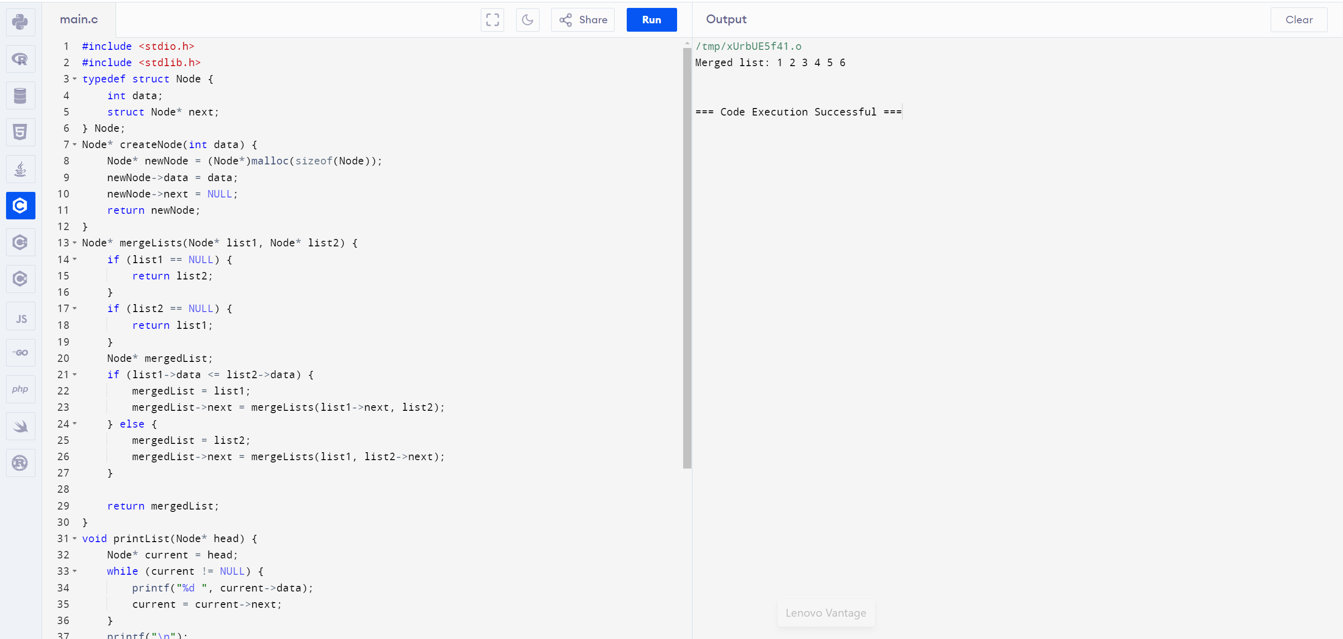

10. Implement a C Program for Binary search tree - search for a element, min element and Max element

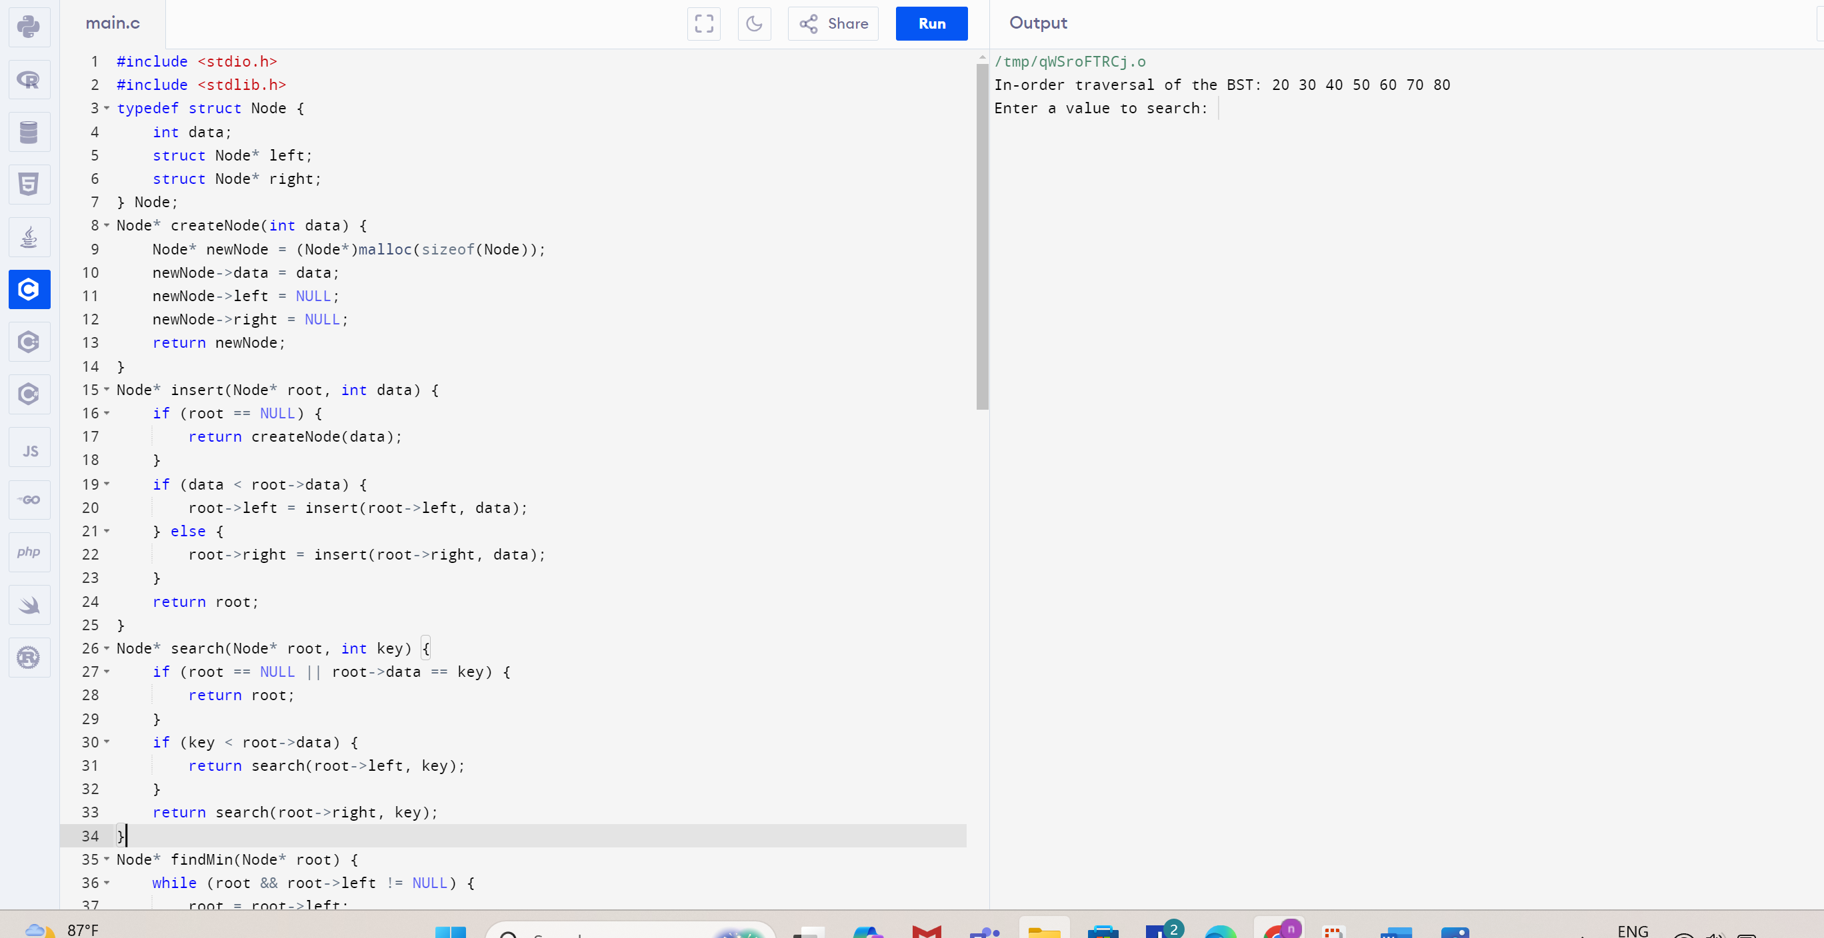

11. Implement a C Program Given an array of reg nos need to search for particular reg no

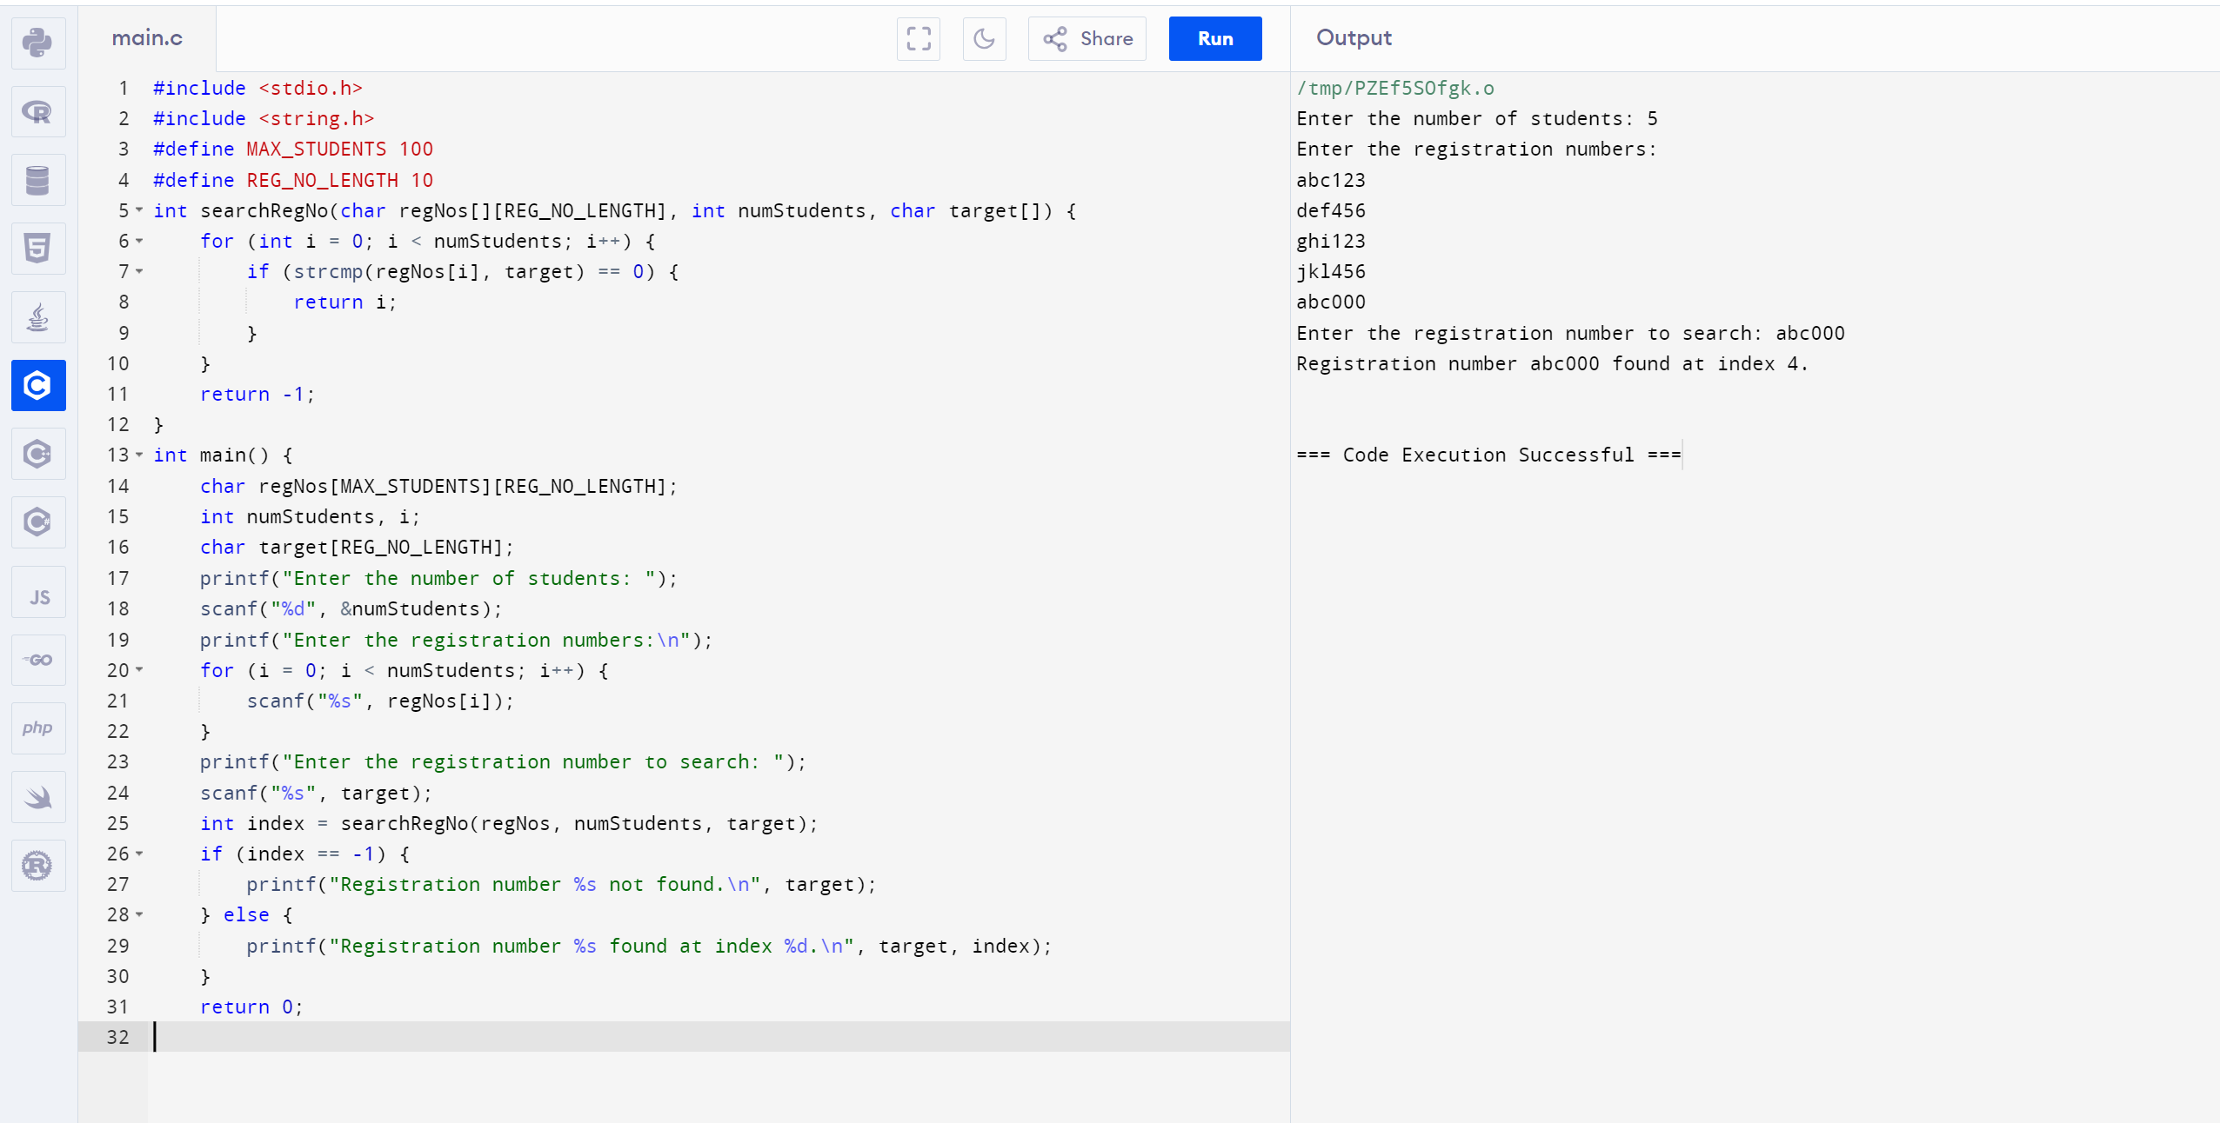

12. . Implement a C Program for Haystack. There are two strings needle and haystack (or hay). You need to check if all the characters in the needle are present in haystack or not. If yes then return True (1) or False (0)

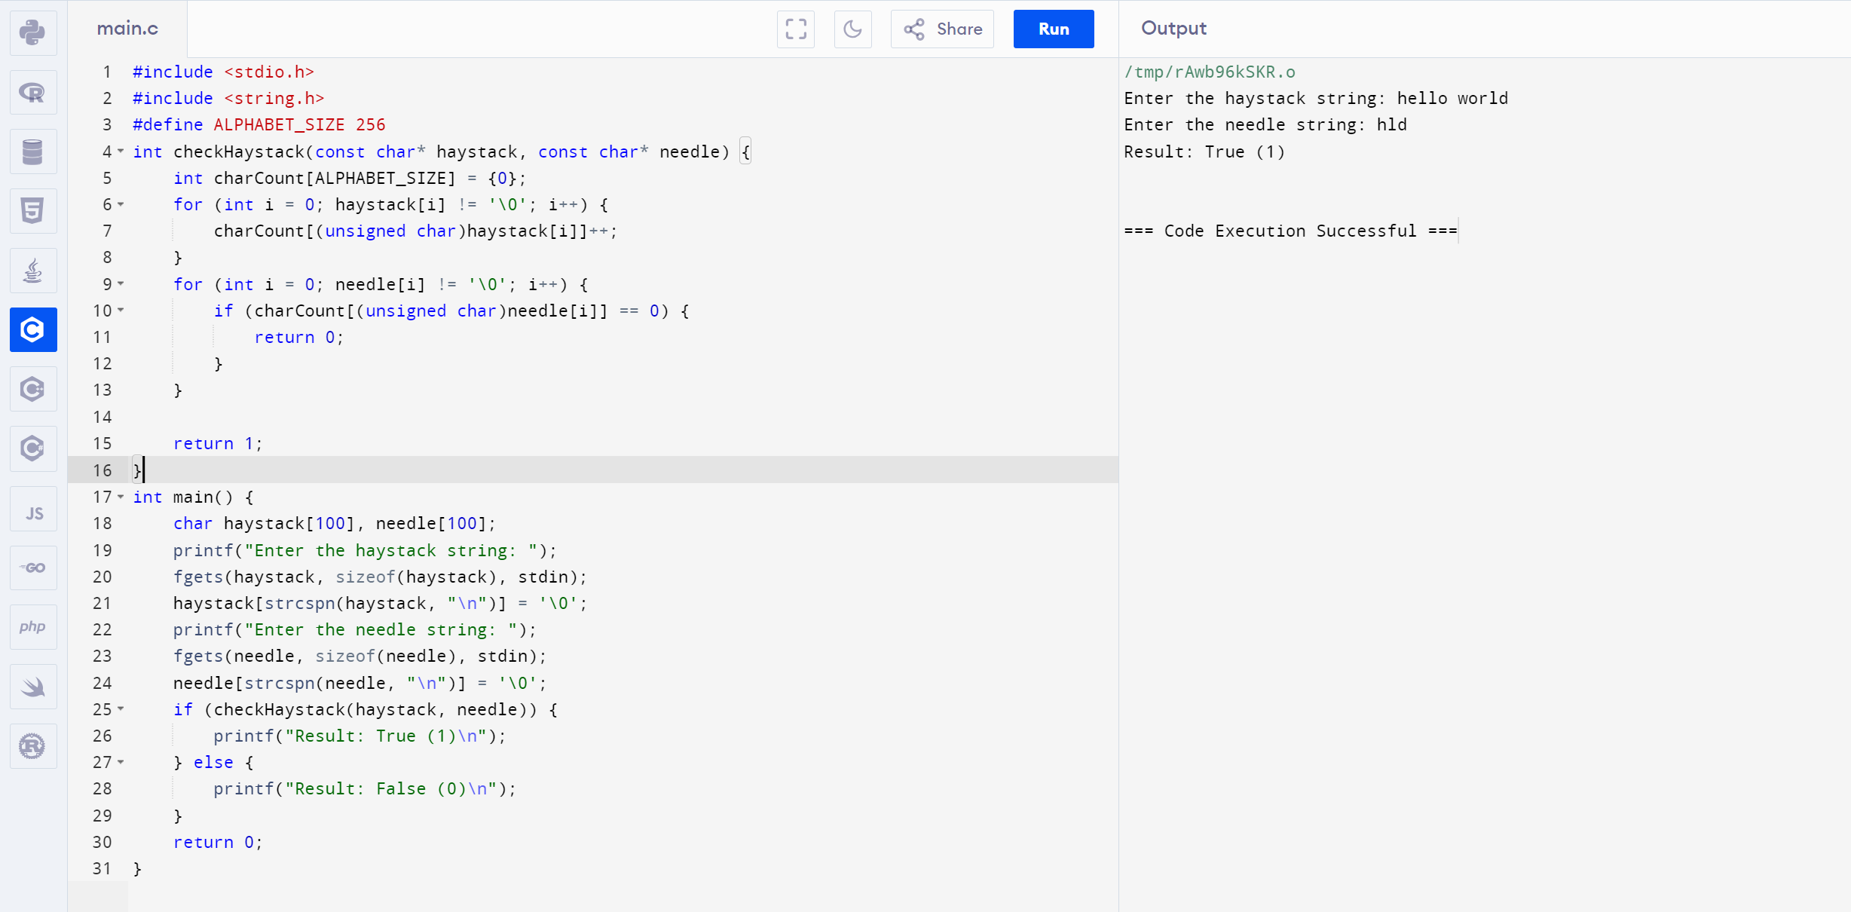

13. Write a program in C to count the frequency of each element of an array.

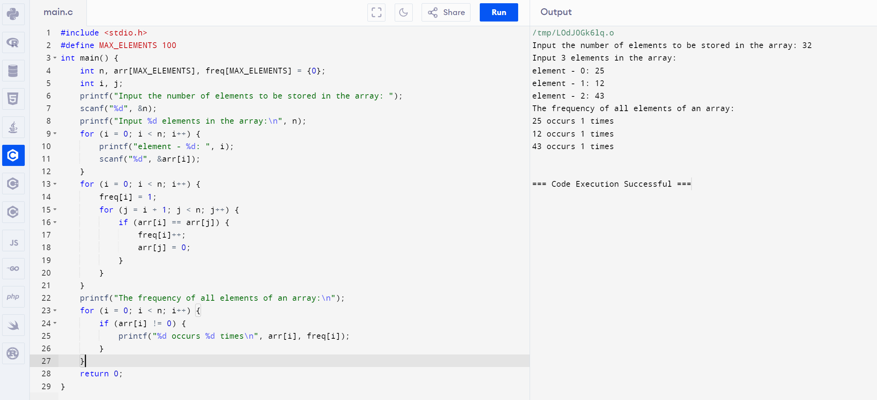

14. Implement a C Program for Given Graph convert array and print minimum edges (Prim’s Algorithm)

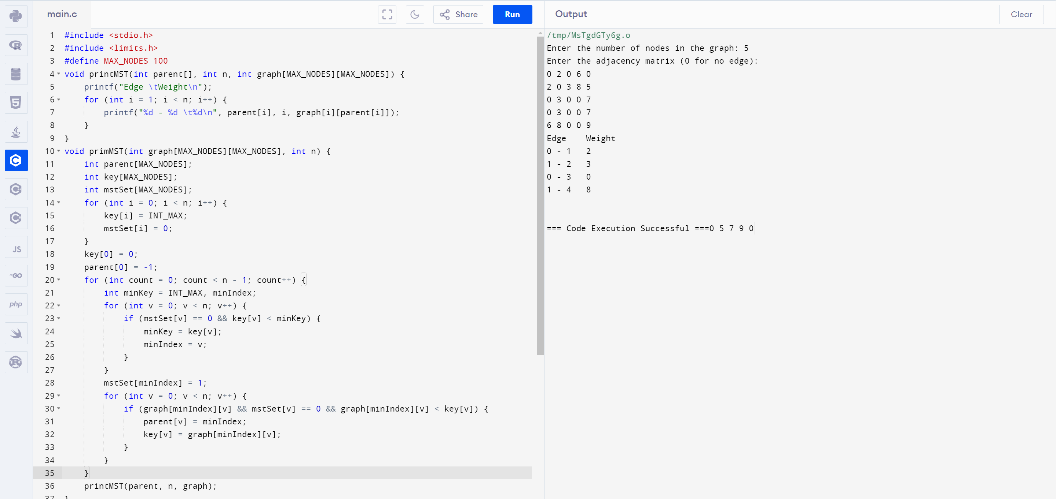

15. Write a program in C to separate odd and even integers into separate arrays.

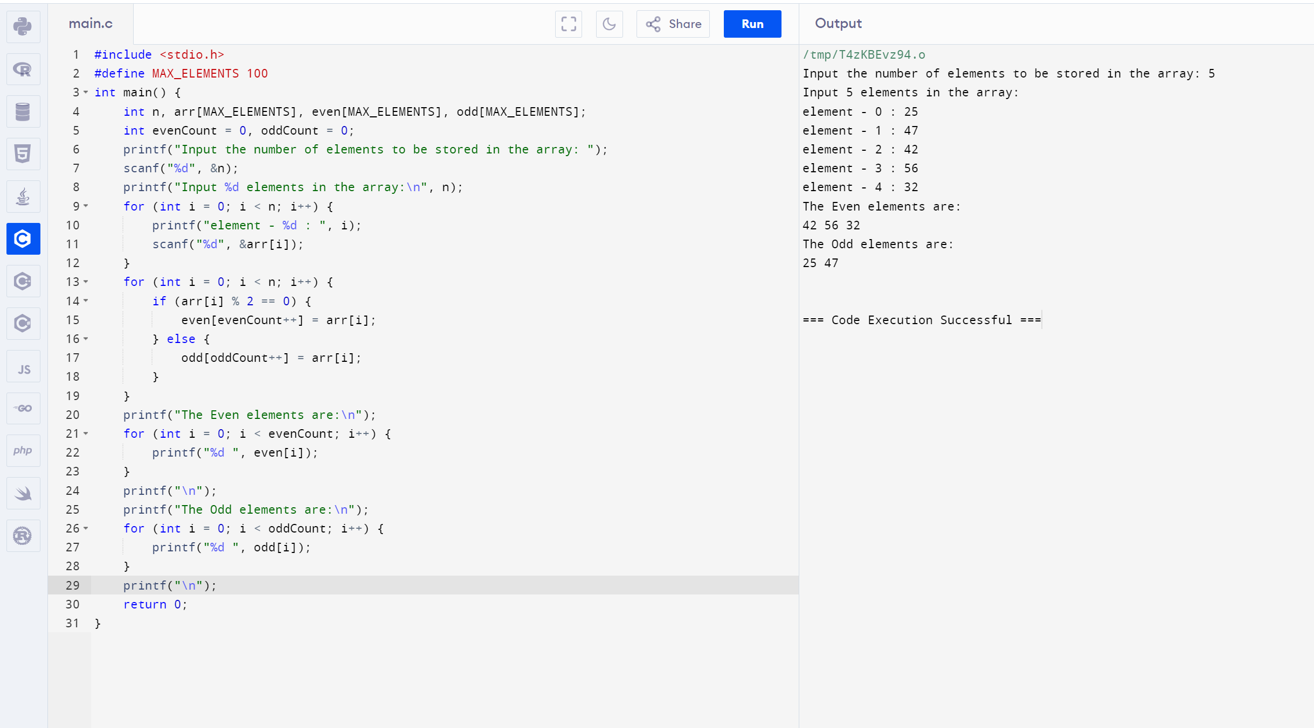

16. Implement a C Program for Given Graph - Print valid path (BFS or DFS)

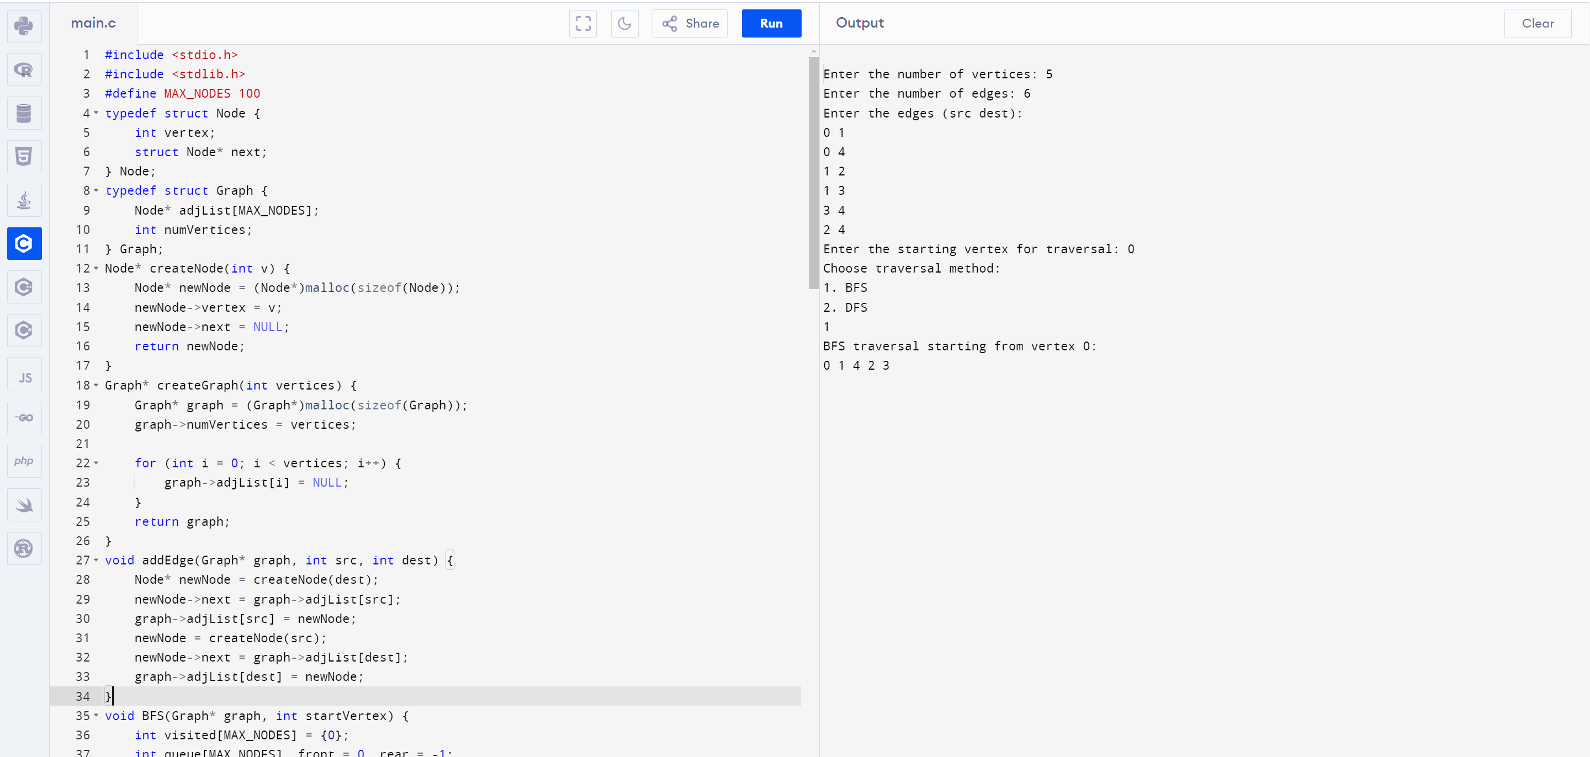

17. Implement a C Program sum of Fibonacci Series using recursion

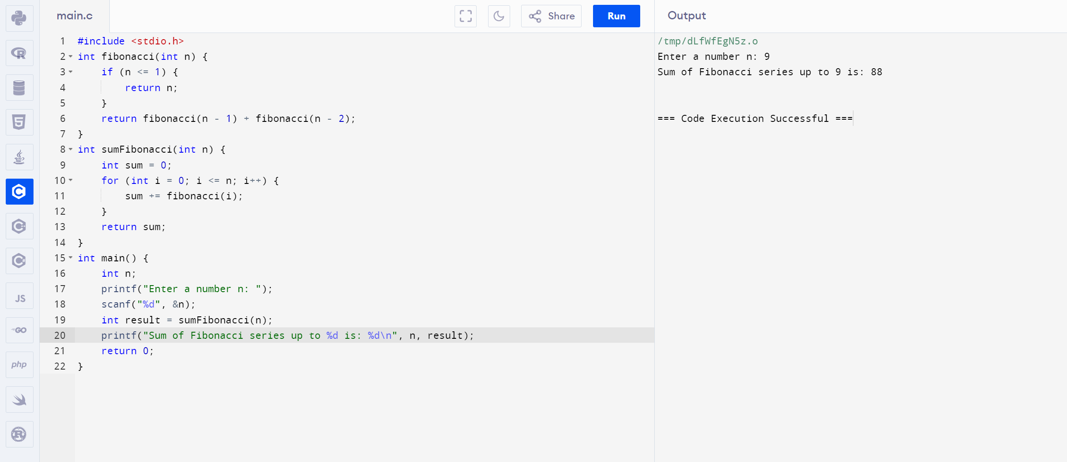

18. Implement a C Program to perform heap sort

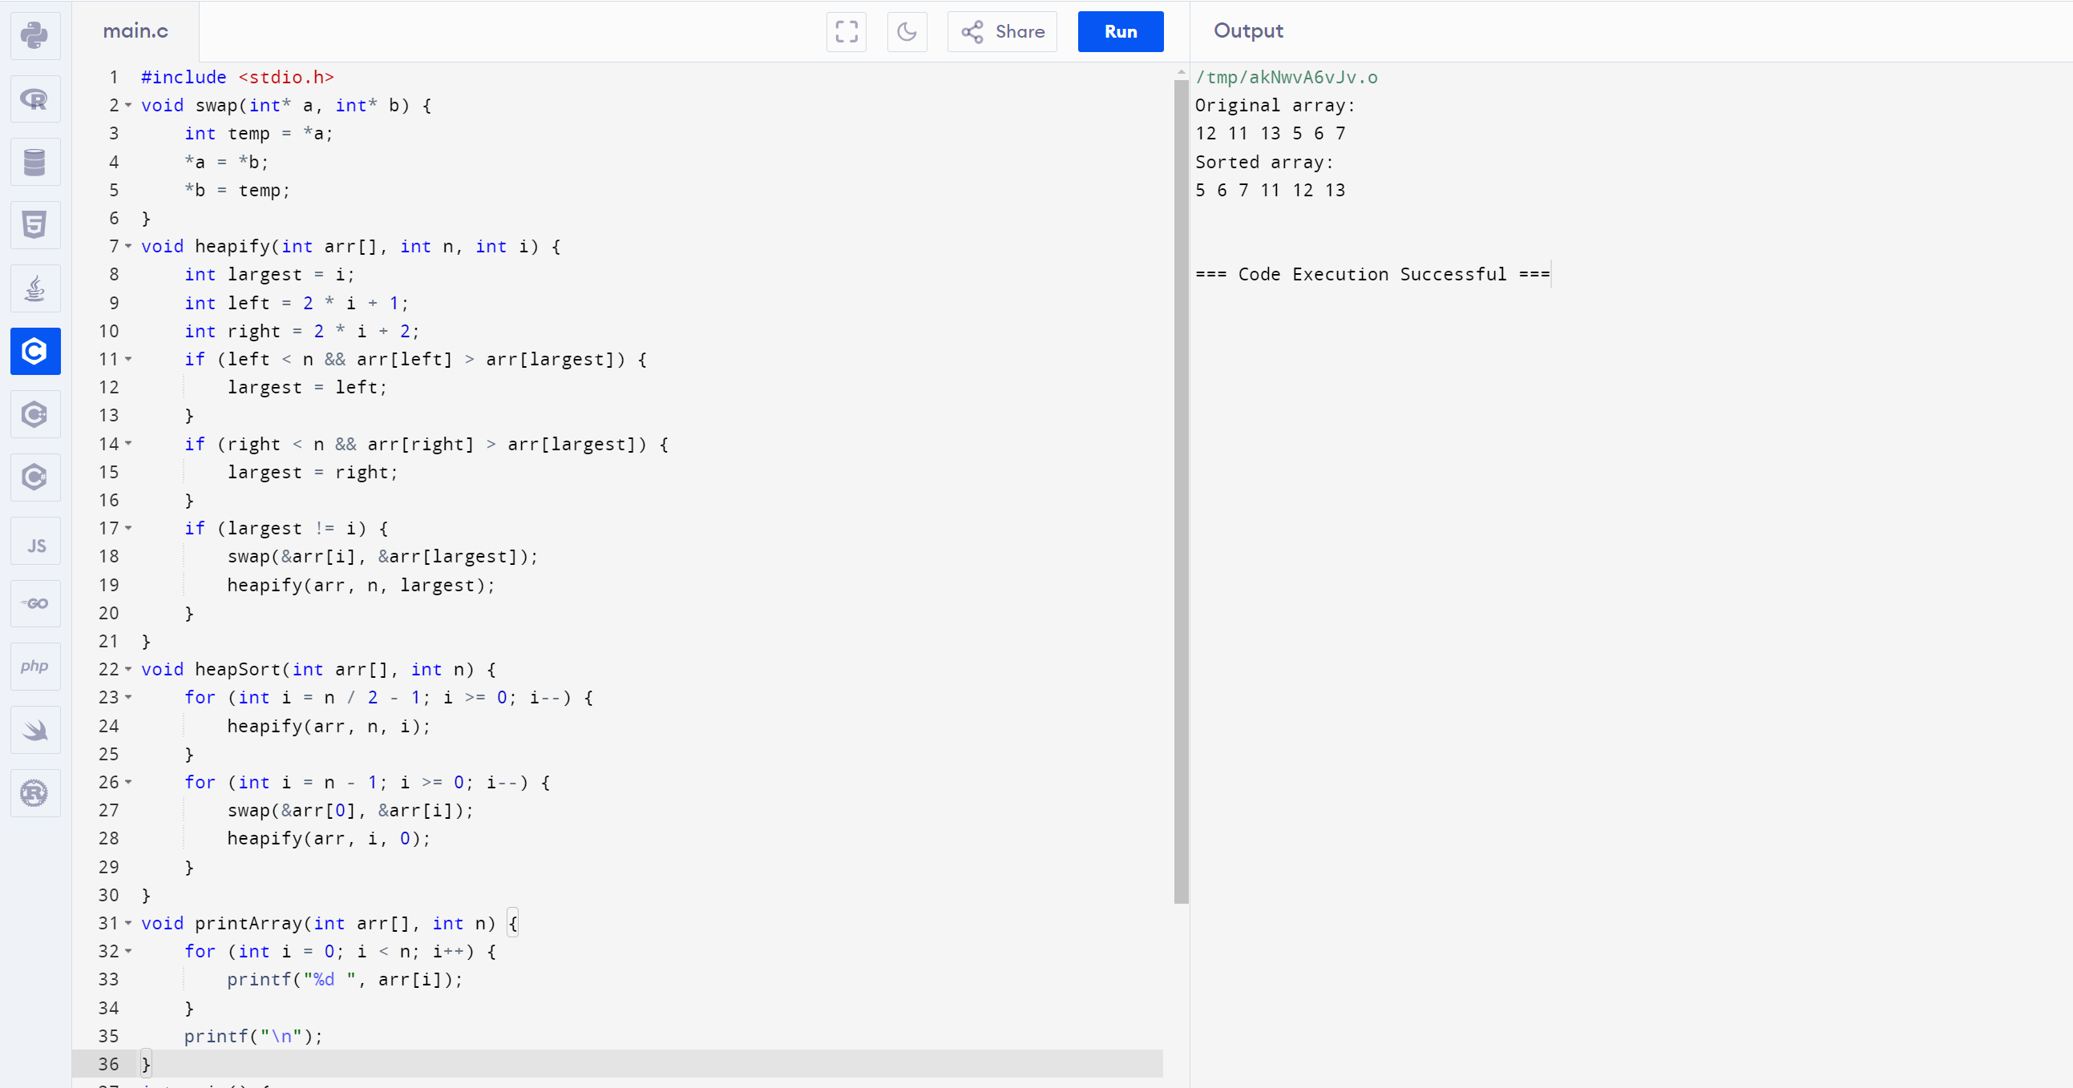

19. Implement a C Program for Finding factorial of a number using recursion

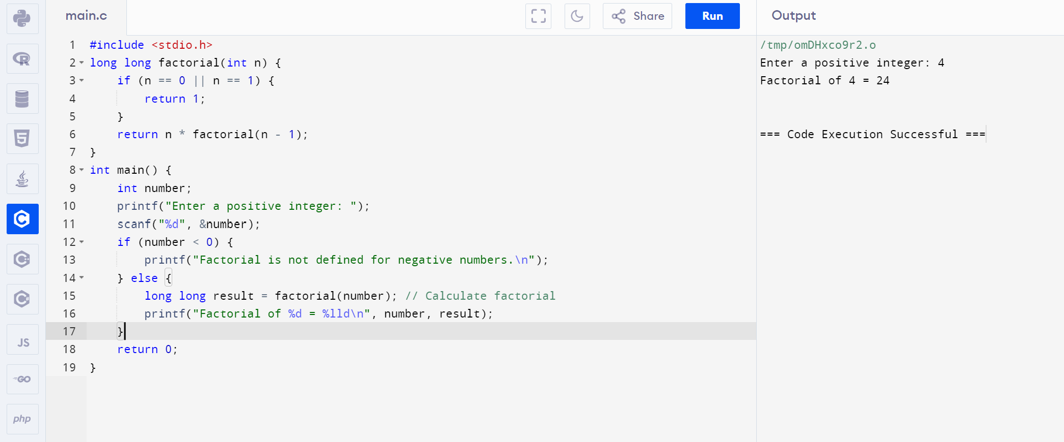

20. Implement a C Program to perform quick sort

